1, SQL Statement: SELECT, FROM, WHERE, GROUP BY, HAVING, ORDER BY.

2, DISTINCT, TOP X (must be numeric), LIKE, NOT LIKE, IS NULL, IS NOT NULL, IN(‘X’,’X’), BETWEEN AND, LIKE%_, INTO(SELECT…INTO…), EXISTS(return ture)

3, (Buyer + ’in’ + Department) AS Sponsor || RTRIM(Buyer) + ‘in’ + RTRIM(Department) AS Sponsor

4, The process of using an SQL JOIN operation to join two tables is called joining the two tables. When tables are joined using an equal to condition is called an equijoin. When people say join, 99.99 percent of the time.

Explicit join: SELECT * FROM A join B on A.Key = B.Key

Implicit join: SELECT * FROM A, B WHERE A.Key = B.Key

5, A SQL subquery is often described as a nested query, a query within a query. Note that SQL queries using subqueries are still single table queries in the sense that only the columns of the top-level query can be displayed in the query result.

6, SQL subqueries and SQL joins both process multiple tables. A subquery can only be used to retrieve data from the “top table”. A join can be used to obtain data from any number of tables, including the ‘top table’ of the subquery.

7, UNION: The result is all the row values in one or both tables. (duplicated: UNION ALL)

INTERSECT: The result is all the row values common to both tables.

EXCEPT: The result is all the row values in the first table but not the second.

8, Relation: A relation is a two-dimensional table that has the following characteristics: Rows contain data about an entity. Columns contain data about attributes of the entities. All entities in a column are of the same kind. Each column has a unique name. Cells pf the table hold a single value. The order of the columns is unimportant. No two rows may be identical.

9, Domain integrity constraint: The requirement that all the values in a column are of the same kind is known as the domain integrity constraint. The term domain means a grouping of data that meets a specific type definition. Columns in different relations may have the same name.

10, Table—relation—file. Column—attribute—field. Row—tuple—record.

11, In a relation as defined by Codd: The rows of a relation mush be unique. There is no requirement for a designated primary key.

12, Functional dependency: A functional dependency occurs when the value if one (set of) attribute(s) determines the value of a second (set of) attribute(s). The attribute on the left side of the functional dependency is called the determinant. Functional dependency may be based on equations. Functional dependencies are not equations.

Student ID -> Student name.

Student ID -> (Dorm name, Dorm room, Fee)

(Quantity, Unit price) -> Extended Price

13, What makes determinate values unique? A determinant is unique in a relation if and only if it determines every other column in the relation. You cannot find the determinations of a functional dependencies simply by looking for unique values in the column: Data set limitations. Must be logically a determinant.

14, Key: A Key is a combination of one or more columns that is used to identify rows in a relation. A composite key is a key that consist of two or more columns. A candidate key is a key that determines all of the other columns in a relation.

A primary key is a candidate key selected as the primary means of identifying rows in a relation. There is only one primary key per relation. The primary key may be a composite key. The ideal primary key is short, numeric and never change.

A surrogate key is an artificial column added to a relation to serve as a primary key. DMBS supplied. Short numeric and never changes – an ideal primary key. Has artificial values that are meaningless to users. Normally hidden in forms and reports.

A Foreign Key is the primary key of one relation that is placed in another relation to form a link between the relations. A foreign key can be a single column or a composite key. The term refers to the relation in which they appear as foreign key values.

15, Database Integrity: three constrains, domain integrity constraint, entity integrity constraint, referential integrity constraint. The purpose of these three constrains taken as a whole, is to create database integrity, which means that the data in our database will be useful, meaningful data.

16, Normal Forms

1NF: A table that qualifies as a relation is in 1NF and has a primary key.

2NF: A relation is in 2NF if all of its non-key attributes are dependent on all of the primary keys (entire primary keys).

3NF: A relation is in 3NF if it is in 2NF and has no determinants except the primary key.

BCNF (Boyce-Codd Normal Form): A relation is in BCNF if every determinant is a candidate key.

17, ADD Column ALTER TABLE table_name ADD column_name datatype;

Eg: ALTER TABLE Students ADD Address varchar(255)

DROP Column ALTER TABLE table_name DROP COLUMN column_name

ALTER Column ALTER TABLE table_name ALTER COLUMN column_name datatype

18, What is meant by the cardinality of a relationship?  
Answer: In the E-R model, there are two types of cardinality—the maximum cardinality and the minimum cardinality. The maximum cardinality is the maximum number of entity instances that can participate in a relationship instance. There are three types of maximum cardinality: one-to- one (1:1), one-to-many (1:N) and many-to-many (N:M). The minimum cardinality is the minimum number of entity instances that must participate in a relationship instance. This number is generally zero (0) or one (1). If the number is zero, then participation by that entity instance is optional (O)—it does not have to be in a relationship with an instance of the other entity. If the number is one, then participation by that entity instance is mandatory (M)—it must participate in a relationship with an instance of the other entity. In a binary relationship there are four (4) possible sets of minimum cardinalities—(O-O), (O-M), (M-O) and (M-M).

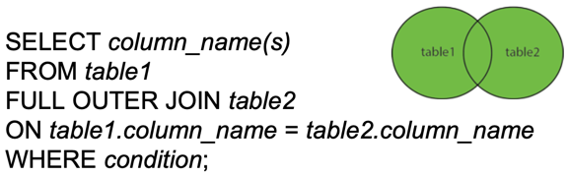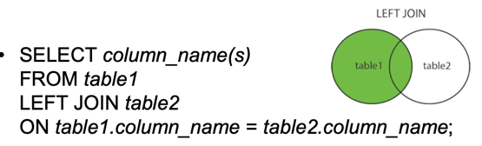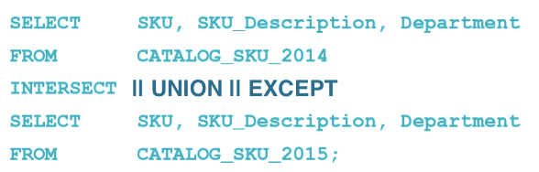

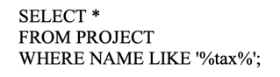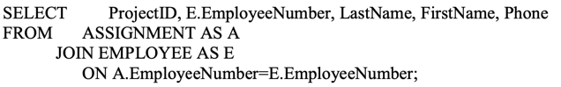

*Only two tables can be queried by using a subquery. Answer: FALSE

*Two or more tables are joined by giving the table names in the WHERE clause and specifying the equality of the respective column names as a condition in the GROUP BY clause. Answer: FALSE

*All relations are tables, but not all tables are relations. Answer: TRUE

*A characteristic of a relation is that the rows of a relation may hold identical values. Answer: FALSE

*If by knowing the value of A we can find the value of B, then we would say that B is functionally dependent on A. Answer: TRUE

*Given the functional dependency A → (B, C), then it is true that A → B and A → C. Answer: TRUE

It is possible to have a relation that does not have a key. Answer: FALSE

*A candidate key is one of a group of keys that may serve as the primary key in a relation. Answer: TRUE

*A referential integrity constraint is used to make sure the values of a foreign key match a valid value of a primary key. Answer: TRUE

*A relation is in 2NF if and only if it is in 1NF and all non-key attributes are determined by the entire primary key. Answer: TRUE

*A relation is in Boyce-Codd Normal Form (BCNF) if and only if it is in 3NF and every determinant is a candidate key. Answer: TRUE

*In E-R modeling, an attribute describes the characteristics of an entity. Answer: TRUE